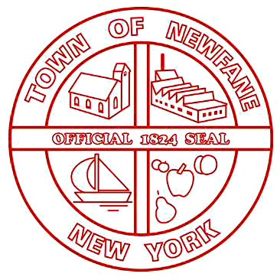
SUPERVISOR
716-778-8531

TOWN CLERK
716-778-8822
FAX 716-638-4183

ASSESSOR
716-778-8827

TAX COLLECTOR
716-778-6052

BUILDING INSPECTOR
716-778-5947

WATER/SEWER
716-778-8132

TOWN OF NEWFANE
2737 Main Street
Newfane, New York 14108

FAX 716-638-4261
JUSTICE COURT
2896 Transit Road
Newfane, New York 14108
716-778-9292

HIGHWAY
716-778-8844

WATER/SEWER
MAINTENANCE
716-778-8587

6176 McKee Street
Newfane, New York 14108

TDD 1-800-662-1220

RESOLUTION NO. 62 – 2023

THE TOWN BOARD OF THE TOWN OF NEWFANE
AUTHORIZES THE HIGHWAY SUPERINTENDENT TO PURCHASE
2023 VOLVO EC220E WITH HYDRALIC DIRECT LINK THUMB,
42” BUCKET AND 48” PROMACK MOWER ATTACHMENT IN JANUARY 2024

WHEREAS, The Town of Newfane Highway Superintendent is in need of additional equipment in
order to fulfil his duties in the most productive and efficient manner, and

WHEREAS, Highway Superintendent, Jon Miller, has presented a sound purchase plan which includes utilizing 2024 Budget allocation from the Machinery Item III of $156,396, 2023 SAM Grant Funding,
in the amount of $50,000, 2023 Budget Surplus from Machinery Equipment Item III in the amount of $50,000 and a portion of 2023 Budget Surplus of $23,000 from the General Repairs Item 1 and

WHEREAS, the cost of this equipment will not exceed $270,000.00, now therefore be it

RESOLVED, the Town Board of the Town of Newfane hereby authorizes the purchase in January 2024
of the above-referenced equipment.

John Syracuse, Supervisor _____________________________

Laura Rutland, Councilwoman _____________________________

Sue Neidlinger, Councilwoman _____________________________

Richard Coleman, Councilman _____________________________

Troy Barnes, Councilman _____________________________

DATED: December 29, 2023

CERTIFICATE OF CLERK

STATE OF NEW YORK
COUNTY OF NIAGARA
TOWN OF NEWFANE

______________________________
Mildred Kramp, RMC, CMC
SEAL Town Clerk Town of Newfane

